This project is generously funded by [NSF](https://www.nsf.gov/awardsearch/showAward?AWD_ID=1901704&HistoricalAwards=false) STEM+C. This exploratory project examines and assesses the effectiveness of a Logic Programming (LP) approach to integrate computing into middle school science education. Researching LP as a strategy to integrate computing into STEM offers an interesting and viable approach for the STEM + C field. While LP is not a new programming approach, it is under-explored in the STEM + C field where the focus is more on visually-based programming such as block-based programming (e.g., Scratch). Through logic programming, students will learn to represent STEM subject-matter knowledge in an explicit and precise manner, while practicing critical thinking and logical reasoning, and developing computer models based on scientific investigation and problem-solving. A key advantage of LP is in its simplicity and generalizability, and this project will provide valuable information about its effectiveness for STEM content area curriculum development.

More about this project: <https://education.ufl.edu/stem-c/>

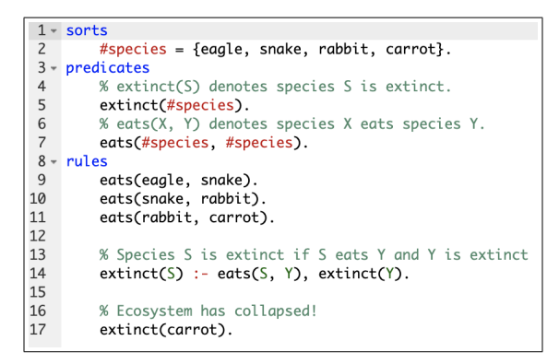

Food chain problem example in onlineSPARC

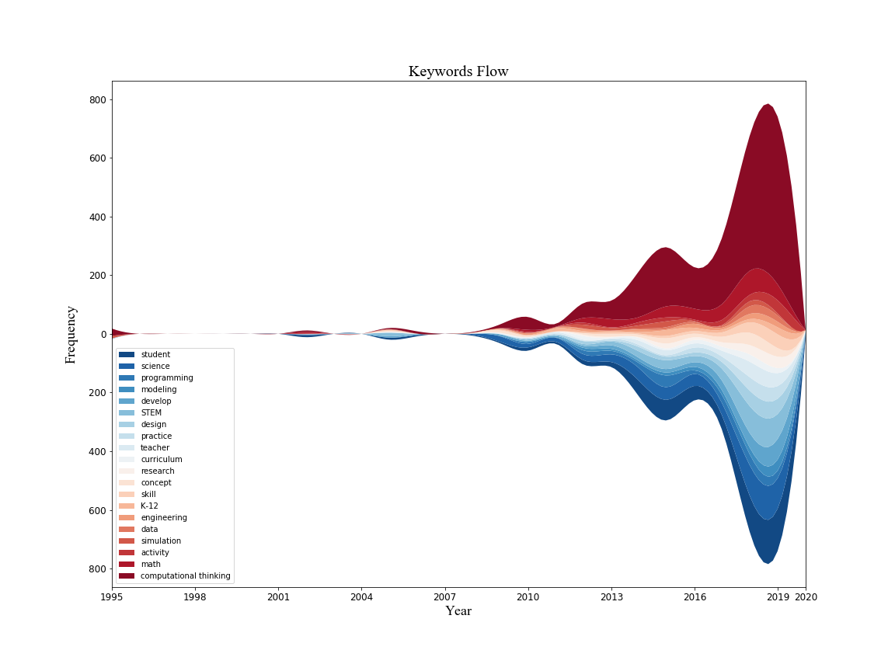

Keyword analysis of STEM + C literature

Publications

Nguyen, V. T., Zhang, Y., Jung, K., Xing, W., & Dang, T. (2020, January). VRASP: A Virtual Reality Environment for Learning Answer Set Programming. In *International Symposium on Practical Aspects of Declarative Languages* (pp. 82-91). Springer, Cham.

Du, H., Xing, W., & Zhang, Y. (2021, June). A Debugging Learning Trajectory for Text-Based Programming Learners. In *Proceedings of the 26th ACM Conference on Innovation and Technology in Computer Science Education (ITiCSE) V.2* (pp. 645-645).

Du, H., Xing, W., & Pei, B. (in press). Automatic Text Generation Using Deep Learning: Providing Large-Scale Support for Online Learning Communities. *Interactive Learning Environments*. doi: 10.1080/10494820.2021.1993932 (Partially supported)

Du, H., Xing, W., Pei, B., Zeng, Y., Lu, J., & Zhang, Y. (2022, April). Trends and Issues in STEM + C Research: A Bibliometric Perspective. In *Proceedings of the 14th International Conference on Computer Supported Education (CSEDU)* (Vol. 1, pp. 69-80).

Hansen, Z., Du, H., Eckel, R., Lugo, J., Xing, W., & Zhang, Y. (2022, August). A Preliminary Data-driven Analysis of Common Errors Encountered by Novice Answer Set Programmers. In the *Technical Communication Proceedings of the 38th International Conference on Logic Programming (ICLP).*